**Week 7**

**Supplier Database**

**-Tanisha Gotadke (1BM21CS229)**

create database supplier;

use supplier;

create table supllier(

sid varchar(20),

sname varchar(20),

city varchar(20),

primary key(sid)

);

DESC supllier;

create table parts(

pid varchar(20),

pname varchar(20),

color varchar(20),

primary key(pid)

);

create table catlog(

sid varchar(20),

pid varchar(20),

cost varchar(20),

primary key(sid,pid),

foreign key(pid)references parts(pid),

foreign key(sid)references supllier(sid)

);

insert into supllier values(10001,'acme widget','bangalore');

insert into supllier values(10002,'johns','kolkata');

insert into supllier values(10003,'vimal','mumbai');

insert into supllier values(10004,'reliance','delhi');

insert into parts values(20001,'book','red');

insert into parts values(20002,'pen','red');

insert into parts values(20003,'pencil','green');

insert into parts values(20004,'mobile','green');

insert into parts values(20005,'charger','black');

insert into catlog values(10001,20001,10);

insert into catlog values(10001,20002,10);

insert into catlog values(10001,20003,30);

insert into catlog values(10001,20004,10);

insert into catlog values(10001,20005,10);

insert into catlog values(10002,20001,10);

insert into catlog values(10002,20002,20);

insert into catlog values(10003,20003,30);

insert into catlog values(10004,20003,40);

select pname from parts where pid IN (select pid from catlog);

select sname from

(select c.sname,count(distinct a.pid) as cnt from catlog a

left join parts b on a.pid=b.pid

left join supllier c on c.sid=a.sid group by 1) a

where cnt=(select count(distinct a.pid) from catlog a

left join parts b on a.pid=b.pid);

select distinct sname from

(select c.sname,b.pname,b.color from catlog a

left join parts b on a.pid=b.pid

left join supllier c on c.sid=a.sid )a

where color='red';

select A.pname from parts A

left join catlog B on A.pid=B.pid

left join supllier C on B.sid=C.sid where lower(c.sname)='acme widget'

and a.pname not in (select A.pname from parts A

left join catlog B on A.pid=B.pid

left join supllier C on B.sid=C.sid where lower(c.sname)<>'acme widget')

;

select a.sid from

(select A.pid,C.sid,cost from parts A

left join catlog B on A.pid=B.pid

left join supllier C on B.sid=C.sid )A

left join

(select A.pid,avg(cost) as cost from parts A

left join catlog B on A.pid=B.pid

left join supllier C on B.sid=C.sid where cost is not null group by 1 )B on A.pid=B.pid

where a.cost>b.cost

select p.pid,s.sname

from suppliers s,catalog c,parts p

where c.pid=p.pid and s.sid=c.sid and c.cost=(select

max(c1.cost)

from catalog c1

where c1.pid=p.pid)

order by s.sname;

**Queries**

**1.** Find the pnames of parts for which there is some supplier.

select pname from parts where pid IN (select pid from catlog);

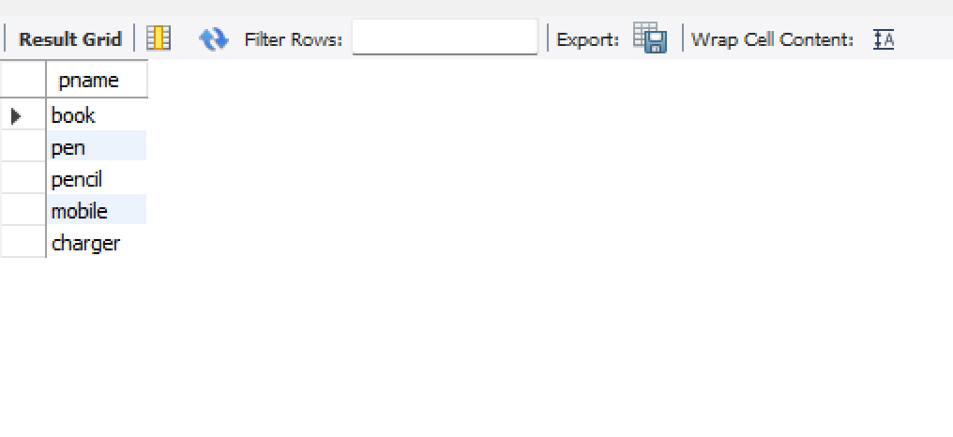

**2.** Find the snames of suppliers who supply every part.

select sname from

(select c.sname,count(distinct a.pid) as cnt from catlog a

left join parts b on a.pid=b.pid

left join supllier c on c.sid=a.sid group by 1) a

where cnt=(select count(distinct a.pid) from catlog a

left join parts b on a.pid=b.pid);



**3.**Find the snames of suppliers who supply every red part.

select distinct sname from

(select c.sname,b.pname,b.color from catlog a

left join parts b on a.pid=b.pid

left join supllier c on c.sid=a.sid )a

where color='red';

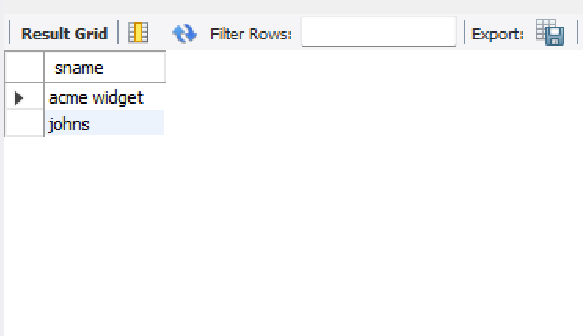

**4.**Find the pnames of parts supplied by Acme Widget Suppliers and by no one else.

select A.pname from parts A

left join catlog B on A.pid=B.pid

left join supllier C on B.sid=C.sid where lower(c.sname)='acme widget'

and a.pname not in (select A.pname from parts A

left join catlog B on A.pid=B.pid

left join supllier C on B.sid=C.sid where lower(c.sname)<>'acme widget')

;

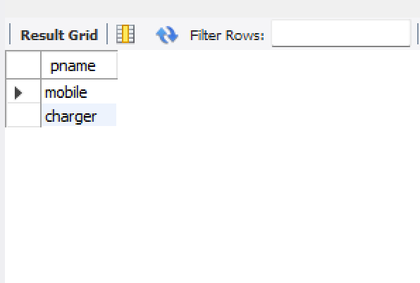

**5.**Find the sids of suppliers who charge more for some part than the average cost of that part (averaged over all the suppliers who supply that part).

select a.sid from

(select A.pid,C.sid,cost from parts A

left join catlog B on A.pid=B.pid

left join supllier C on B.sid=C.sid )A

left join

(select A.pid,avg(cost) as cost from parts A

left join catlog B on A.pid=B.pid

left join supllier C on B.sid=C.sid where cost is not null group by 1 )B on A.pid=B.pid

where a.cost>b.cost

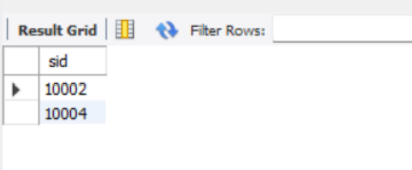

**6.**For each part, find the sname of the supplier who charges the most for that part.

select p.pid,s.sname

from suppliers s,catalog c,parts p

where c.pid=p.pid and s.sid=c.sid and c.cost=(select

max(c1.cost)

from catalog c1

where c1.pid=p.pid)

order by s.sname;

